a.

**select** *

**from** student

**where** city **in** ('Казань','Москва')

**order** **by** **name** **desc**

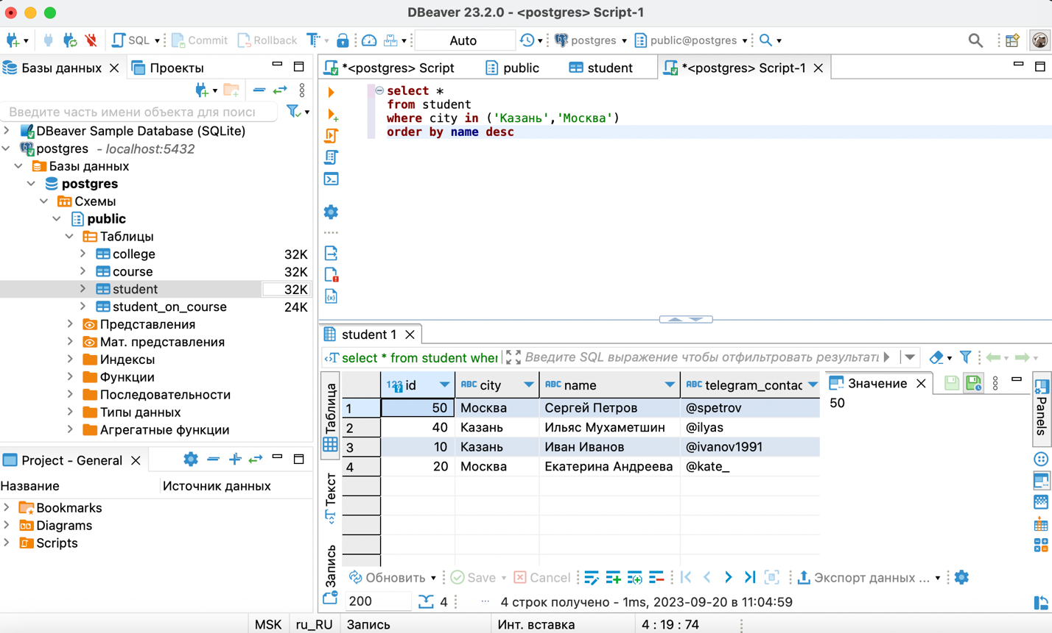

b.

**select**

'университет: ' || **name** || '; количество студентов: ' || **size** **AS** "полная информация"

**from** college

**order** **by** "полная информация"



c.

**select** *

**from** college

**where** id **in** (10,30,50)

**order** **by** **size**, **name**



d.

**select** *

**from** college

**where** id **not** **in** (10,30,50)

**order** **by** **size**, **name**



e.

**select** **name**, amount_of_students

**from** course

**WHERE** amount_of_students **BETWEEN** 27 **AND** 310

**order** **by** **name**, amount_of_students

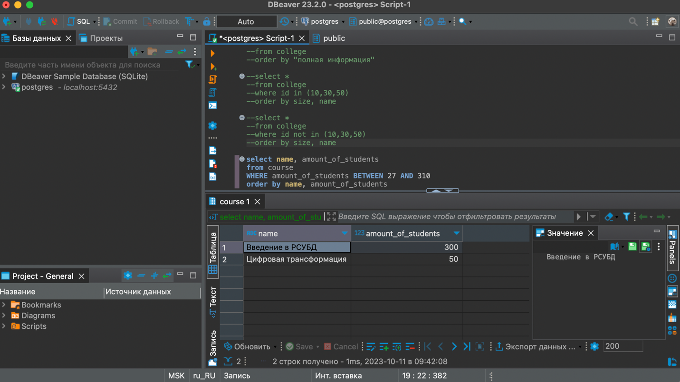

f.

**SELECT** **name** **FROM** student

**UNION**

**SELECT** **name** **FROM** course

**ORDER** **BY** **name** **DESC**

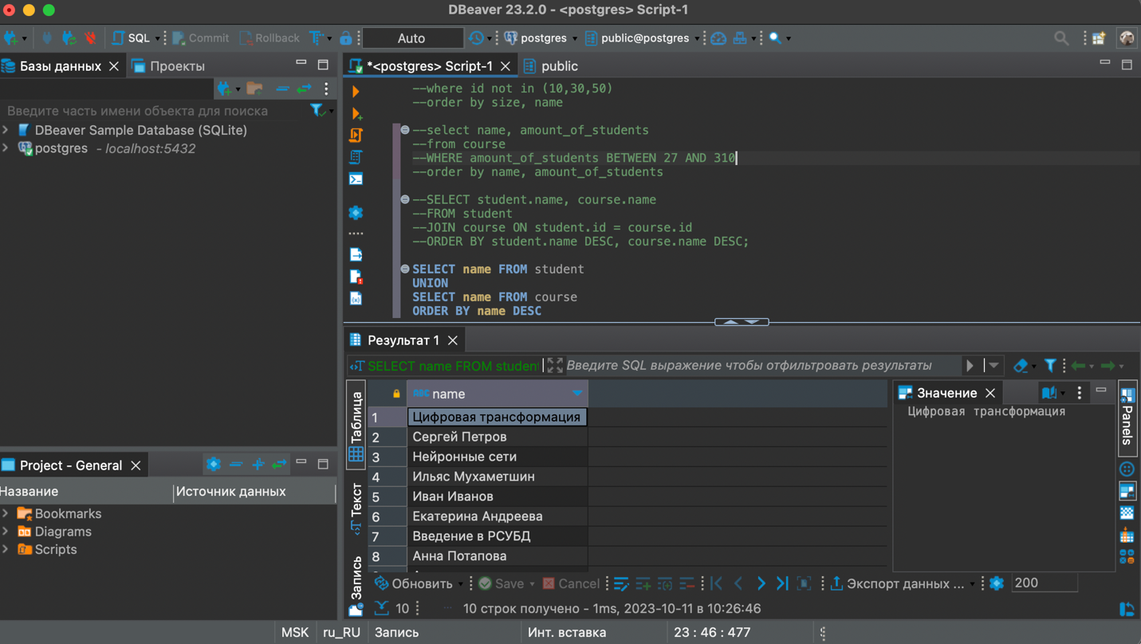

g.

**SELECT** **name**, 'университет' **AS** object_type **FROM** college

**UNION**

**SELECT** **name**, 'курс' **AS** object_type **FROM** course

**ORDER** **BY** object_type **DESC**, **name** **DESC**

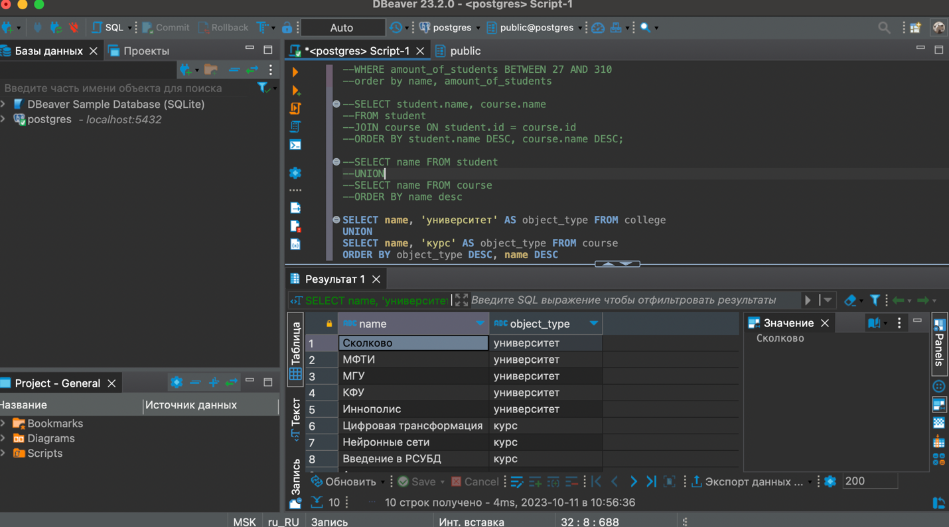

h.

**SELECT** **name**, amount_of_students

**FROM** course

**ORDER** **BY** **CASE**

**WHEN** amount_of_students = 300 **THEN** 0

**ELSE** 1

**END**, amount_of_students

**LIMIT** 3

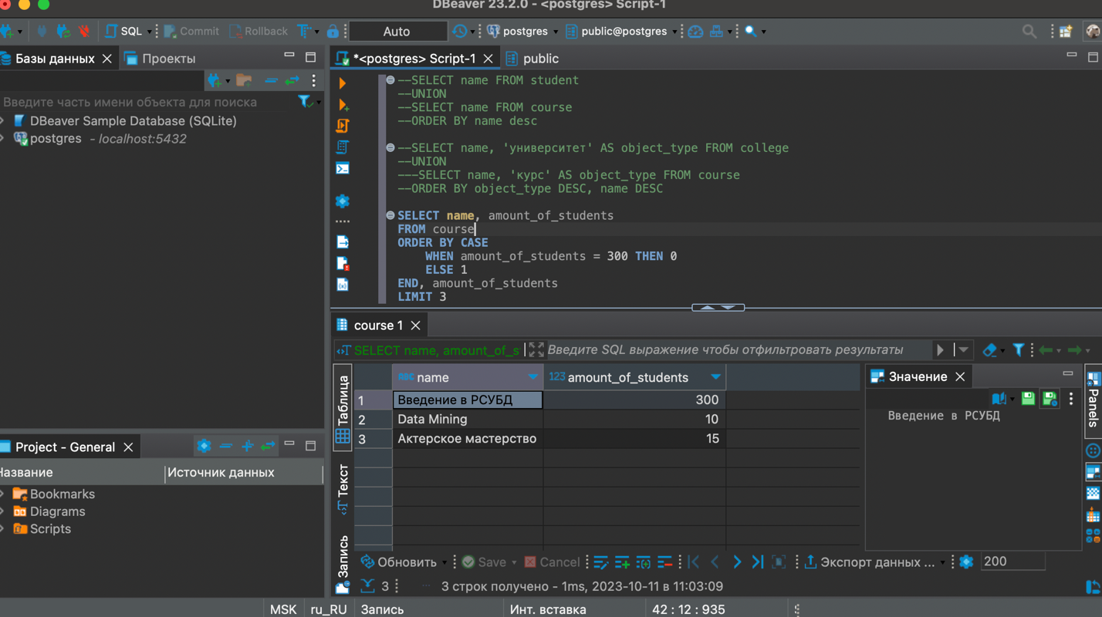

i.

**INSERT** **INTO** course (id, **name**, is_online, amount_of_students, college_id)

**VALUES** (60, 'Machine Learning', **false**, 17, (**SELECT** college_id **FROM** course **WHERE** **name** = 'Data Mining'))

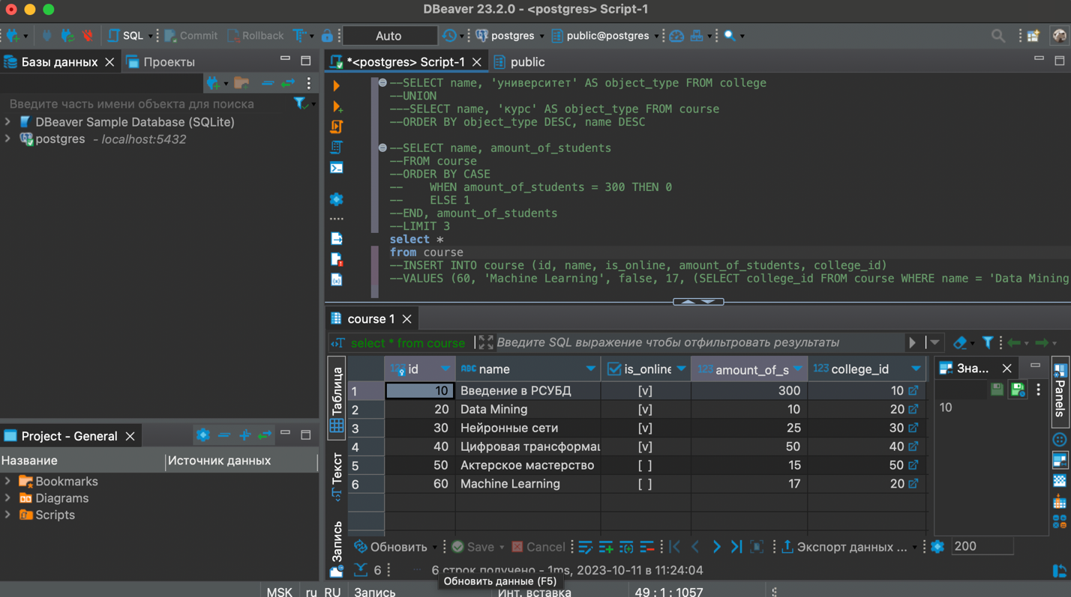

k.

**SELECT** student.**name** **as** student_name,

course.**name** **as** course_name,

college.**name** **as** student_college,

student_on_course.student_rating

**FROM** student

**JOIN** course **ON** student.id = course.id

**JOIN** college **ON** student.id = college.id

**JOIN** student_on_course **ON** student.id = student_on_course.id

**where** student_on_course.student_rating > 50 **and** course.amount_of_students > 5000

**ORDER** **BY** student.**name**, course.**name**

